Hello <client name>,

As a valued client, I am reaching out to you during this time to ask how you and your family are coping. The uncertainty of world events and rising cost of consumer goods is creating a lot of uncertainty and stress. For some, it is also creating financial challenges and worry about what happens next. As your advisor, it is my job to listen to your concerns and look for possible ways to help. When it comes to questions about your short-term and long-term finances, we need to look at your overall investment plan.

When it comes to your long-term investment strategy, daily news reports on the latest market rise and fall can sometimes make us react without keeping the bigger picture in mind. You need to remember that investing is a long-term plan and part of that long-term plan is accepting that markets will go up and markets will go down. While markets do rise and fall it is important to note that over the long-term, markets have historically moved higher.

Your investment strategy includes segregated funds. Segregated funds offer guarantees that provide protection against market downturns. They combine many of the features of a mutual fund, with elements of an insurance contract. This includes guarantees that are not available with traditional mutual funds. These guarantees range from 75 to 100% of your principal investment, depending on the guarantee option.

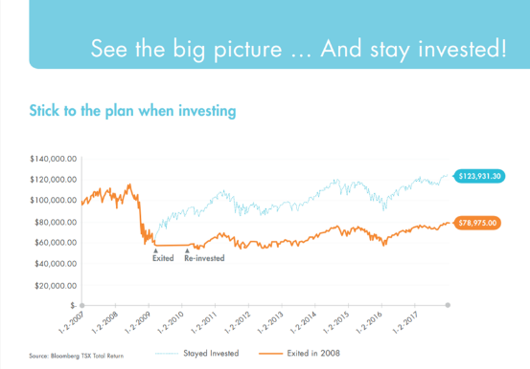

*The graph shows just how different an outcome can be if you let your emotions affect your decision-making.*

When it comes to investing, you must remember to put your   
emotions aside. Investing is about strategy, education,   
knowledge and commitment.

It might be a good time to book a virtual meeting to discuss   
any concerns or questions you may have. Let’s connect and see how you are doing.

Sincerely,